Module 6:

Creating Resources

Contents

Module Overview 1

Lesson 1: Resource Types 2

Work Resources 3

Cost Resources 4

Material Resources 5

Budget Resources 6

Lesson 2: Creating Resources 7

Creating a Work Resource 8

Creating a Material Resource 14

Overview of Costing in Microsoft Project 15

Creating a Cost Resource 16

Creating a Budget Resource 17

Entering a Fixed Cost 19

Practice: Creating Resources 21

Lesson 3: Assigning Material, Cost and Budget Resources to Tasks 22

Assign a Cost Resource to a Task 23

Assign a Material Resource to a Task 26

Assign a Budget Resource to a Project Summary Task 29

Practice: Working with Resources 33

Summary 34

6

.

# Module Overview



Projects are resource driven. Resources are defined as: people, equipment, materials, contractors and costs. A project cannot be carried out if there are no resources performing the project tasks. In the previous modules we discussed how to create and refine the tasks of a project schedule. Tasks represent the “What” of the project – what work needs to be performed. The resources are going to be doing the work and they are considered the “Who”. In future modules we will be discussing the “when” and for “how much” which are established when assignments are created.

After completing this module you will be able to:

1. Understand resource types
2. Create resources: work, cost, budget and material
3. Assign cost, budget and material resources to tasks

# Lesson 1: Resource Types



Without resources doing the work projects would remain a planned schedule. Project 2010 has the ability to offer multiple types of resources to help accomplish the work of a project. The different types of resources are intended to provide flexibility to address most types of resources required during the planning and management of a project.

In this lesson we will discuss the resource types and their intended use:

1. Work resources
2. Cost resources
3. Materials resources
4. Budget resources

## Work Resources



Assigning work resources to a project will allow for resource requirement forcasting and project scheduling based on resource availability. Work resources are usually human resources but can also be facilities, equipment rental and other types of resources. Resource costs can be forecasted using resource assignments to provide projected project budgets. Each work resource entry will contain a resource type, grouping, availability calendar, rate tables and other relevant data.

Effective uses of Work Resources are:

* Individual people – actual named resources
* Generic resources – these are job titles that can be used as placeholders to identify resources by skill type, skill level or if a resource is unknown. For example: DBA, Developer level 1, Event Planner, Plumber
* Group resources – used to state the quantity of a specific type of resource. For example: Helpdesk, Movers, Painters, Attendees, Members
* Facilities – a room or area that must be reserved for a period of time
* Contracted resources – external contracted labor
* Equipment – a machine used for a particular number of hours

## Cost Resources



Cost Resources are defined as any thing that will add a dollar(s) cost to a project. Use of Cost resources enables the scheduler to add estimated costs during the planning phase of the project. These costs will be updated into the baseline. When actual costs become available during tracking, the actual costs will be updated and compared against the original estimates to provide a variance.

Cost resources will inherently increase the cost for a task and for the project. Cost resources have no effect on work or duration. The cost value is applied to tasks as a flat amount at the time of assigning the cost expense to a task.

Effective uses of Cost resources are:

* Flat estimated cost:
  + Travel expenses estimated in advance
  + Flat amount equipment rental
  + Flat amount facilities rental
* Fees: license fees, permits
* Estimates for meetings expenses or food provided for events
* Estimates for miscellanous project expenses
* Estimates for a flat amount for a fixed bid contracted resource when hours are not accumulated

**Best Practice:** *Project 2010 allows for as many cost resources as needed but for simplicity try to consolidate cost resources and keep them to a limited number. The type of reporting required for the project would drive the quantity of cost resources that will be needed.*

## Material Resources



Material resources are defined as consumables. For example: Reference books for a new product might cost $50 each and 20 books are needed. A material resource would be created with a cost of $50 per book. An assignment would be entered for a task for 20 books. As a result $1,000 is added to the cost of the project. During tracking, the actual number of books would be entered to adjust the quantity if necessary.

The cost of the material resources are added to the total cost of the project and updated into the project baseline. Material resources do not affect work or duration.

Effective uses of Material resources are:

* Construction: create a material resource for the cost of 1 foot of trim. Enter the number of feet required for the task
* Conference: create a material resource for the cost of giveaway bags. Enter the number of giveaway bags needed for the conference
* Servers: create a material resource for the cost of 1 server. Enter the number of servers needed for the project.

**Best Practice:** *If your project will be using a large quantity of materials such as a construction project, using Excel might be less work and a more effective means of keeping track of materials.*

## Budget Resources



Budget resources are used to estimate the total budget of a project as work and cost values. The estimates are held by the project summary task and used for reporting and comparison purposes. Budget values can be compared to the baseline and actual values to determine project health which may be viewed as custom created reports. The budget values are assigned to the project summary task and apply to the entire project.

Effective uses of Budget resources are:

* When you want to be aware of the total cost estimated budget for a project and how it relates to baseline cost and actual costs.
* When you want to be aware of the total work estimated budget for a project and how it relates to baseline work and actual work.

Budget cost and budget work figures may be timephased and variably spread over the duration of the project schedule. The budget for a project might not be distributed evenly and the timephased ability allows for a variable distribution of the funds and work.

Budget values are entered amounts and not calculated. Once the budget values are entered they will not be recalculated by the Project 2010. Any changes to the values are done manually.

**Best Practice:**  *Organizations should set a standard for the values used for budgets and what is included. Some organizations feel it should be the actual budget for the project. Others feel it should be the budget plus reserve amounts. There should be a consistency placed within an organization.*

# Lesson 2: Creating Resources



Resources available for assignment to tasks reside on the Resource Sheet. Resources are either entered manually or imported using Active Directory, Outlook , or copy and paste from a source like Excel or Word. This lesson will teach you how to manually enter resources on the Resource Sheet.

Fixed costs are additional flat amount costs that a project might incur. Learning how to work with fixed costs will enable you to include all projected costs for a project.

At the end of this lesson you will be able to:

1. Create a work resource
2. Create a material resource
3. Create a cost resource
4. Create a budget resource
5. Enter fixed costs for a project

## Creating a Work Resource



A work resource is usually a named person or generic skill type. They are resources that will have hours of work and the following formula will apply:

[image](http://blogs.msdn.com/blogfiles/project/WindowsLiveWriter/AssignmentUnitsinProject2010_9314/image_2.png)

* The resource cost is stored in the resource record on the Resource Sheet.
* The number of hours of work will come from the assignment of the resource to the task.
* Assignments units will be the quanitity of the resource.

Resources are entered on the Resource Sheet.

**To display the Resource Sheet:**

* Click **Task** 🡪 **Gantt Chart view** 🡪 **Resource Sheet**

The default table view of the Resource Sheet is called the entry table view which is shown below. This table is a subset of many resource fields of information that are available. This table represents the most important fields that should have values entered for a resource. More information is accessible through the Resource Information dialog box.

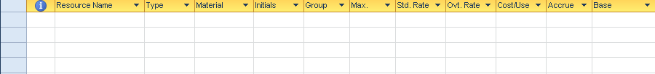

To enter a resource, type the resource name in the “Resource Name” field. The Resource Name is the key field for the resource data.

**TIP:** *Many reports and assignment views will display resources in alphabetical order. A standard of last name first name allows for easy location of resources while making assignments. The database does not allow commas or other special characters. When entering first names it is best to use full first names and avoid using nicknames.*

After the name is entered, several fields will be populated with default information. The view below shows the default information that is automatically entered:



The values for these fields are:

**Type:**  Work is the default and will establish Robert Smith as a work resource. Other values are material and cost and can be changed by clicking the down arrow and changing the type selection.

**Material:**  used for Material resources only – skip for work and cost resources.

**Initials:**  enter full initials for resources. Initials may be substituted on Gantt Charts or reports as needed to shorten reports.

**Group:**  Group is technically a free use field. It is usually used for department, location or skill set. It is one of the few fields populated in the task data when an assignment is created. This information is used to generate reports by groupings of resources. A best practice is that an organization set a standard for the use of this field.

**Max units:** The value shown above is in the default percentage format but can also be viewed as a decimal value.

To change to a decimal value: Click **File 🡪 Options 🡪Schedule**

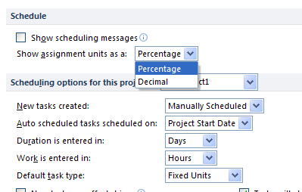

The Max units’ value is an indicator of the quantity of a resource that is available. Typically an individual should always have a value of 1 or 100%. When entering a group resource such as the number of people on the Helpdesk, enter the number of resources in the group. Each resource represents 1 unit. The available quantity of the resource will be determined by number of hours in a day x Max units. For example if there are 5 people on the Helpdesk, enter 5 or 500% in the Max Units column. With 5 available resources each one can work 8 hours per day. Helpdesk will have 40 available hours of work per day. When Helpdesk resources are assigned to a task, the Helpdesk will be not be overbooked until 40 hours have been assigned.

**NOTE:** *Some reference sources recommend using a lesser value in the Max units field to limit a resource’s availability. This can produce variable results when creating assignments.*

**Standard rate:** Enter the loaded rate for the resource. A loaded rate is pay scale plus overhead factors. In most organizations, this figure comes from the accounting department with periodic updates. Default is rate per hour but a rate may be enterd as /yr a yearly rate or /w for a weekly rate.

**Overtime rate:** When using overtime, a rate for the overtime hours may be entered in this field. It will affect only overtime hours entered.

**Cost per use:** An extra value that may be added to a task over and above the Standard Rate for the resource. For example: A repairman is called to fix a refrigerator. The repairman charges a transportation charge, and hourly rate, plus parts. The cost per use is the transportation charge and would be applied to every task the repairman would be assigned to.

**Accrue at:** Cost accrual is an indicator of a point in time when costs are incurred. Cost accrual settings have 3 options: incur costs at the start of the task, incur costs at the end of the task, or incur costs throughout the task (prorated). Prorated accrual is the default option.

**Base calendar:** Each work resource will have a resource calendar associated with it. The resource calendar is based on calendars that have been previously established for the project. The Standard Calendar is the default resource Base Calendar. If the base calendar contains company non-working time it is not necessary to reestablish company holidays, statutory holidays, etc. as all of these will be applied to the resources. Use the dropdown list to select the appropriate calendar for a resource.

The Resource Information dialog box is used to record information about a resource that is not captured in the Resource Sheet.

**To view Resource Information dialog box:**

* Double click the resource you wish to access

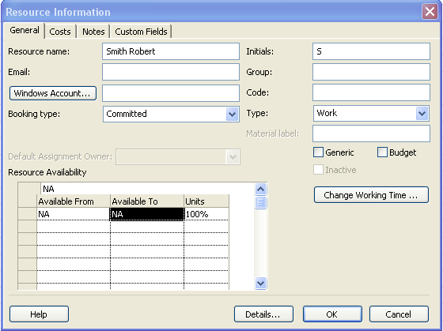

**General tab data**:

**Email:**  reference only for Project 2010 standard

**Windows Account:** Project Server 2010 usage only

**Booking type:**  Project Server 2010 usage only

**Code:** If you have a code associated with a resource, enter it here. Typically this code is a cost center or department cost category. Free use field for users.

**Generic:**  Click this field to indicate that the resource is a generic resource. A generic resource is a skill type resource to be used as a holding value until a human resource is assigned. When generic resources are used, default base calendar for scheduling.

**Budget:** budget resources only

**Inactive:** Project Server 2010 use only

**Resource availability:** Enter dates if the resource is only available for a particular period of time. For example: An outside contractor is hired for a specific length of time. Enter the date ranges the resource will be available.

**To change the resource availability calendar:**

From the General tab, click **Change Working Time** button. The view will appear:

The form looks identical to the form used to change project and base calendars discussed in an earlier module. The view above is the calendar assigned to Smith Robert and it uses the Standard calendar as a base build the calendar for the resource. Changes to this calendar are made in the same way that changes were made to the project calendar.

Click **OK** to close the calendar form.

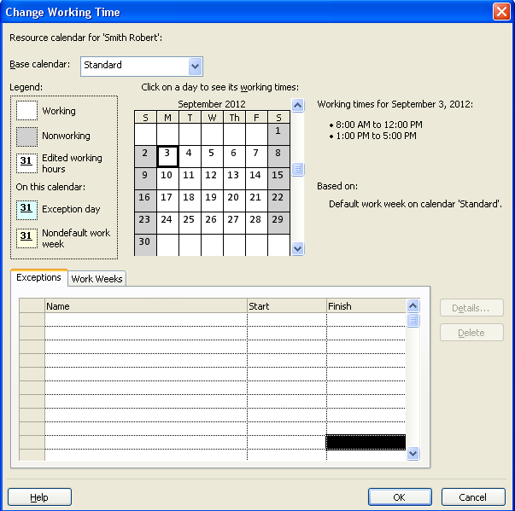

**Cost tab data:**

Resource costs are stored on the Cost tab. A resource may have up to 5 cost tables to accommodate varying rates. The tables are labeled A, B, C, D, and E. Labels may not be changed. Some resources will charge different rates when performing different types of work. Each assignment may be assigned a rate table.

**TIP:**  *If more than one rate table is being used for a resource, enter a note on the Notes tab to help keep track of the purpose of each rate table.*

Most organizations using costing experience periodic rate changes. The effective date allows early storage of future rate adjustments and become active based on a cut off date. If a project spans the cut off date, the tasks before the cut off date of the project will be costed at the earlier date rate and the remaining tasks which exceed the cut off date will contain increased rate. It is easy to see that if a project runs late, the cost of the project could increase when using rate tables.

**TIP:**  *If using resources that come on shore and off shore use the effective date to change rates for resources when they change location.*

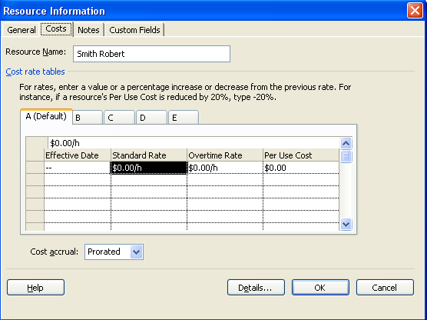

**Notes tab data:**

Resource notes are treated the same as task notes within Project 2010. Resource note data has the same formatting and flexibility as task notes.

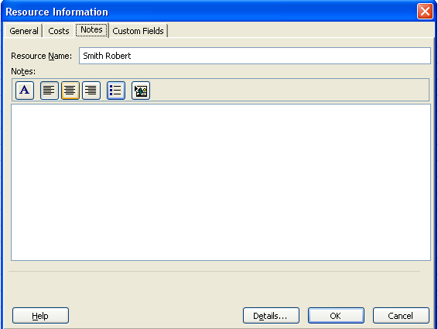

**Custom Fields tab data:**

If custom fields have been created for resources, they will be available through the custom fields tab.

**NOTE:**  *Resources may be imported from Active Directory**and Outlook to be added to the Resource Sheet. Once they are downloaded from these sources, additional information will be required to complete the entries for the resources.*

**To access the download function for resources click:**

* Click **Task** 🡪 **Gantt Chart view** 🡪 **Resource Sheet**
* Click **Resource 🡪 Add Resources**

Add Resource options are shown below.

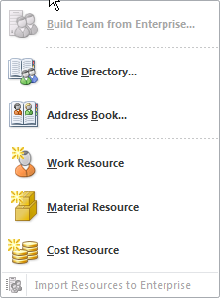

## Creating a Material Resource



Material resources are supplies to be used by the project, such as paint, building materials, equipment, etc. Material resources are valued based on the quantity of material to be used which is assigned to a task.

Below are the fields associated with Material resources.

**Resource name:**  name of the consumable item

**Type:**  Material

**Material label:**  boxes, gallons, feet, each – the label that describes the material

**Standard rate:**  the per unit/each price

**Accrue at:** accrual rate for the material

Material resource entries are shown below:

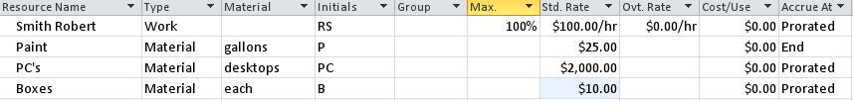

## Overview of Costing in Microsoft Project



Cost in Project 2010 acquires information from many values to accumulate a final cost value per task. Per task cost values rollup to the summary task which will in turn rollup to create a grand total stoed in the Project Summary task. These calculations will occur in both manual and automatic scheduling mode.

The cost values included in the costing formula are:

* Resource work hours
* Fixed costs
* Material costs
* Cost resource values
* Overtime costs and hours

**The cost formula is as follows:**

Number of hours assigned to a resource X the standard rate for the resource

(Adjusted rate depending on rate tables by date) +

Number of hours of overtime assigned to a resource X the overtime rate for the resource

(Adjusted rate depending on rate tables by date) +

Value of cost resources assigned to a task +

Value of fixed cost enter for a task +

Value of material resources (units) assigned X per unit rate =

Total cost for a task

**NOTE:**  *Many of the task tables contain the column “Total Cost”. However, the field is really called “Cost”. There was a visual name change to “Total Cost” to add clarity.*

## Creating a Cost Resource



Cost resources are used to apply estimated costs specific tasks in a project. Estimated costs are entered during the planning stage and tracked when actual costs are entered during the execution or control stage of the project.

**TIP:**  *When naming cost resources include “Cost” as the first word in the name. It will be helpful when assigning cost resources for the name to give an indication of the resource type. Resources appear in alphabetical order when creating assignments and including “Cost” as the first word ensures all Cost resources will be grouped together in the list.*

**To enter a cost resource:**

**Resource name:**  For example: Cost travel, Cost food, Cost room rental, etc.

**Type:** Cost

No other information is required. Below 3 cost resources have been added. The amount of the cost will be added at the time the assignment is created.

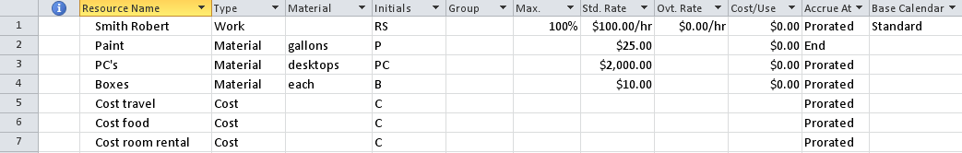

## Creating a Budget Resource



A budget resource is intended to hold the project budget to be used as a comparison against baseline and actual cost and work values. The budget resources are the only resource type that may be assigned to the Project Summary task.

To create a Budget Work resource:

**Resource Name:** ie: Budget work

**Type:** Work

**Set the budget check box:**

* **Double click on the resource** to open the Resource Information dialog box
* Click **General** tab
* Click **Budget check box**
* Click **OK**

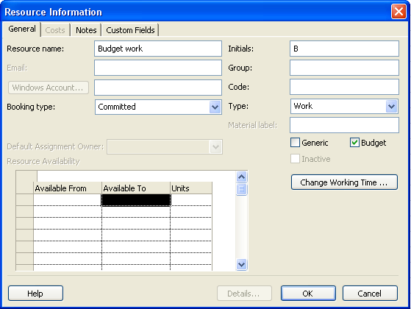

To create a Budget Cost resource:

**Resource Name:** ie: Budget cost

**Type:** Cost

**Set the budget check box:**

* **Double click on the resource** to open the Resource Information dialog box
* Click on the **General** tab
* Click the **Budget check box**
* Click **OK**

Below is an example of what these 2 resources would look like once assigned. The Budget column is inserted to show the budget settings turned on.

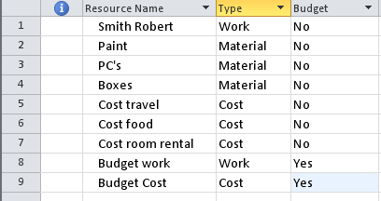

## Entering a Fixed Cost



A Fixed Cost is an extra flat amount value that is applied to a task when necessary. It is included in the total cost formula for a task and will roll up to the total cost for a project. Only flat amount values can be inserted into the Fixed Cost column. When multiple values are needed, they must be manually accumulated and the total entered in the Fixed Cost field.

To view Fixed Cost field:

* **View 🡪 Gantt Chart 🡪 Tables 🡪Cost**  
  OR
* **View 🡪 Gantt Chart**
* Right click in the upper left corner above the task ID numbers and select Cost from the list of tables

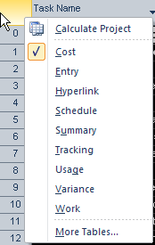

Below is a view of the Cost table with the Fixed Cost column indicated:

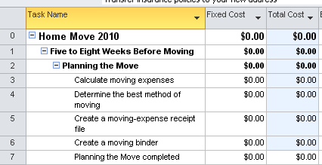

The fixed cost column is the second column from the left on the cost table. Enter in the fixed cost value for the task in the fixed cost column. If multiple values are needed the amounts must be accumulated and entered into this field as a lump sum.

**TIP:** *When entering a fixed cost amount enter a journal note into the notes field. This note will remind you what the value of the expenses were, when they were entered and by whom.*

Task 5 used $100 in office supplies. See below the result of applying $100 to the fixed cost field for task 5.

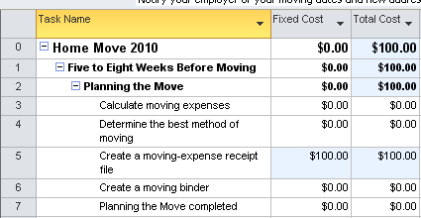

The total value subtotaled into the total cost fields for the summary and project summary tasks. Note that the fixed cost column does not subtotal to the summary values for the fixed cost field.

**TIP:**  *Fixed costs that reside in an external file, such* *as an Excel workbook can be dynamically linked to the fixed cost field for a task by copying the external field and then* **Paste 🡪 Paste Special 🡪 Paste Link 🡪Text Data** *into the fixed cost field for a task*.

*Whenever the source value changes, the value in the fixed cost field will also update. This method is using external links and requires that the files not be moved to avoid breaking the links.*

## Practice: Creating Resources



*The Practice page is where you write detailed instructions for completing work listed as Exercises.*

*Type the Exercise Title and write a brief summary what the student will be doing in the exercise. Then list your ideas what they will be doing.*

*SAMPLE*

*In this practice you will create a Project Server Authentication profile and then configure the local cache settings in Project Professional 2007.*

*Exercise 1: Create Project Server Authentication Profile*

*In this exercise you will create Project Server authentication profile to connect to the Project Web Access site.*

Perform the following exercise on the PS07 virtual machine.

1. *From the* ***Start*** *menu, click* ***All Programs*** *🡪* ***Microsoft Office*** *🡪* ***Microsoft Office Tools*** *and click* ***Microsoft Office Project Server 2007 Accounts****.*
2. *In the* ***Project Server Accounts*** *dialog box, click* ***Add****.*
3. *In the* ***Account Properties*** *dialog box, and complete the following settings and click* ***OK****.*

|  |  |
| --- | --- |
| *Setting* | *Perform the following:* |
|  | |
| *Account Name* | *Type* ***Project Server*** |
| *Project Server URL* | *Type* ***http://epm/pwa*** |
| *When connecting* | *Select* ***Use Windows user account*** |
| *Set as default account* | *Select check box* |

# Lesson 3: Assigning Material, Cost and Budget Resources to Tasks



Once resources have been entered into the resource sheet, they may be assigned to tasks to create assignments. An assignment is applying the “who” (resource) to the “what” (task) to create the “how” and “when” (assignment).

After completing this lesson you will be able to:

1. Create assignments for Cost resources
2. Create assignments for Material resources
3. Create assignments for Budget resources

**NOTE:** *Creating assignments for work resources will be addressed in Module 7*.

## Assign a Cost Resource to a Task



The purpose of assigning a cost resource to a task is to add additional estimated costs that the task might incur. Tasks may have multiple cost resources applied but the same resource name may not be applied more than once. Cost resources will not affect the scheduling of a project.

There are several methods available to assign a cost resource to a task. A few are described below:

Create an assignment using the Assign Resources box:

* Click **Task 🡪 Gantt Chart**
* Click **Resource 🡪 Assign Resources** to display the Assign Resources dialog
* Click on the task you would like to assign a Cost Resource to
* Click the **Cost resource name**
* Enter the amount of the cost in the cost column
* Click **Assign**
* Click **Close to close the box**

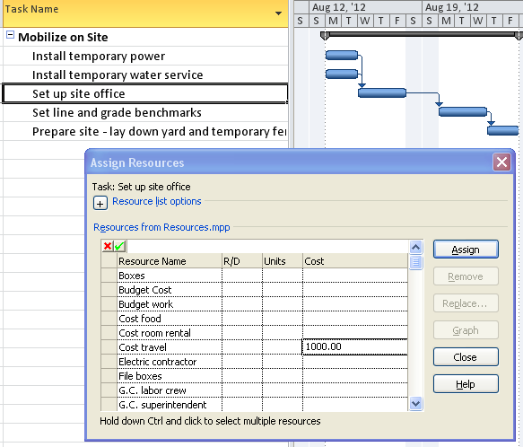

The result of the assignment will appear like this:

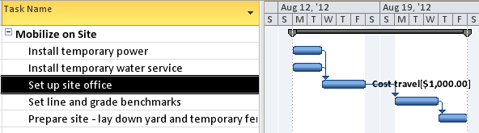

An alternate method of assigning a Cost Resource to a task is through the Task Information dialog box:

* Click **Task 🡪 Gantt Chart**
* Double click on the task you would like to assign the cost resource to
* Click **Resources** tab
* Click on the next open line and select the cost resource to apply
* Enter the cost value in the cost column
* Repeat for additional entries
* Click **OK** to close the box

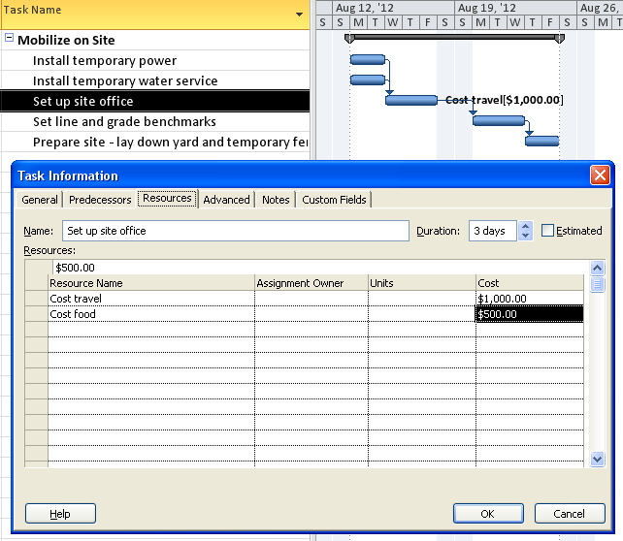

**NOTE:**  *Project 2010 allows entering a new resource name in the Task Information dialog box or the Assign Resources box. The resource will be added to the Resource Sheet as a new resource using the default field values as a work resource which might not be correct for the resource data needed. Additional field values may also be required to complete the resource data correctly.* *It is a best practice is to create resources through the Resource Sheet.*

## Assign a Material Resource to a Task



Assignment of material resources is very similar to assigning a cost resource to a task. A material resource is assigned by entering the number of items for the material resource assignment.

There are several methods of assigning a material resource to a task. A few are described below:

Create an assignment using the Assign Resources dialog box:

* Click **Task 🡪 Gantt Chart**
* Click **Resource 🡪 Assign resources**
* Click the task you would like to assign a material resource to
* Click on the **Material** resource
* Enter the amount of the number of items in the units column
* Click **Assign**
* Click **Close to close the box**

In the example below, 200 Electrical Connectors were assigned to the Install Temporary Power task.

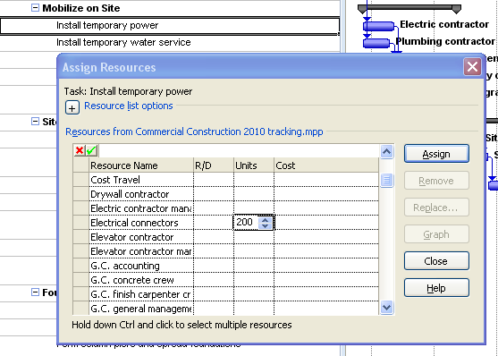

An alternate way of assigning a material resource can be accomplished using the Task Entry view. The Task Entry view is a preset view that displays the Gantt Chart in the upper portion of the screen and the Task Form in the lower portion. The view is shown below.

To display Task Entry view:

* Click **Task 🡪 Gantt Chart 🡪 More Views 🡪 Task Entry 🡪 Apply**
* Right click in the bottom pane and select Work

To create the assignment:

* Click the task you wish to assign the resource to
* Click **Resource Name** field in the lower pane
* Click the down arrow in the Resource Name field to display a list of resources
* Select a material resource
* Enter number of units or items in the units field
* Click **OK** button on the Task Form to enter the assignment

In the example below “Fencing material” is the material resource. On the Resource Sheet the material was entered as $20 per foot. 400 linear feet of fencing was entered in the units column for the assignment. Below is the result of the assignment.

**NOTE:**  *When creating assignments or making changes in the Task Form as part of a split screen, the second button on the right of the view will say “Previous” As changes are made the value will change to “OK”. The “OK” button must be clicked to have the changes take effect.*

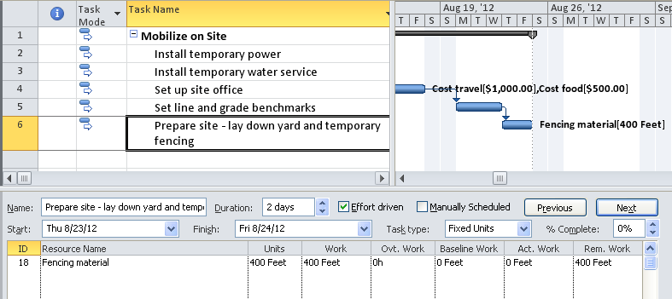

Right click in the bottom pane and select Cost and view will view the cost of the material.

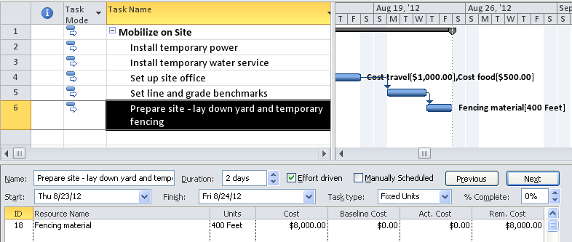

## Assign a Budget Resource to a Project Summary Task



Budget resources are intended to apply to the entire project and are assigned to the Project Summary task only. Both budget costs and budget work values for Budget resources may be entered per project. After the budget amounts are entered they can be fine-tuned to reflect how the budgeted cost or budgeted work is distributed throughout the project schedule.

There are several steps that must be followed to ensure the assignment and values are entered correctly:

1. Create the budget resources on the Resource Sheet (explained earlier in this module)
2. Assign the budget resources to the Project Summary Task
3. Enter the work and cost values for the budget amounts

Perform the following steps from the Gantt Chart view. These steps also assume that Budget Cost and Budget Work are budget resources on the Resource Sheet.

To view the Project Summary task:

* Click  **Format 🡪 Project Summary Task**

To assign budget resources to the Project Summary Task:

* Click **Resource 🡪 Assign Resources**
* Click on the **Project Summary Task**
* Click **Budget Work** in the Assign Resources box
* Click **Assign**
* Click **Budget Cost** in the Assign Resources box
* Click **Assign**
* Click **Close to close the box**

**TIP:**  *If you are not able to assign the budget resources to the project summary task, double check the budget setting for the resources on the resource sheet. Only budget resources can be assigned to the Project Summary task. If they cannot be assigned, the budget flag isn’t turned on.*

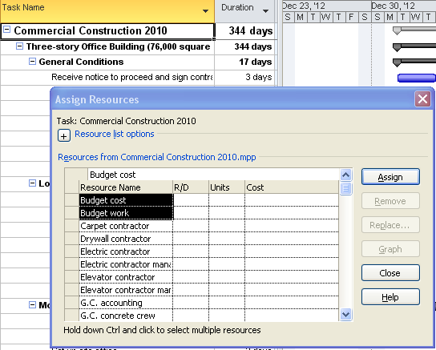

The resource assignment will not show on the Gantt Chart view but may be seen in the Resource Name column in the entry table.

The next step to assigning a budget resource is to enter the amount of budgeted work and budgeted cost for the budget resources. The Task Usage view, with several additional columns is best for entering these amounts. The steps are below:

* Click **Task 🡪 Gantt Chart 🡪 Task Usage**
* On the left side of the view – move the divider bar to the right to display a few columns of data.
* Right click on the **Work** column and insert the **Budget Work** column
* Right click on the **Budget Work column** and insert the **Budget Cost** column
* Move the divider bar to the left so the Task name, Budget Work and Budget Cost columns are in view.
* On the right side of the view:
  + **Right click anywhere 🡪 Detail styles 🡪 Available fields 🡪 Budget Work 🡪 Show** (see below)
  + Click **Budget cost 🡪 Show**
  + Click **Budget work 🡪 Show**
  + Make sure that Budget Work on Budget Cost appear in the “Show these fields” box on the right
  + Click **OK** to close the box

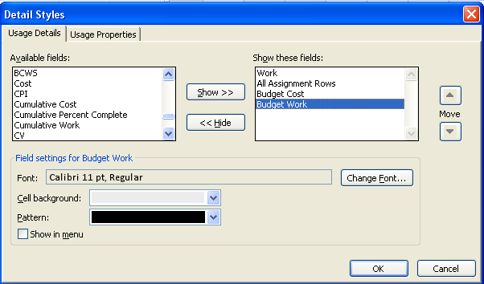

The result is of adding the columns to the Task Usage view are shown below. The timescale has been adjusted to show per month level of detail:

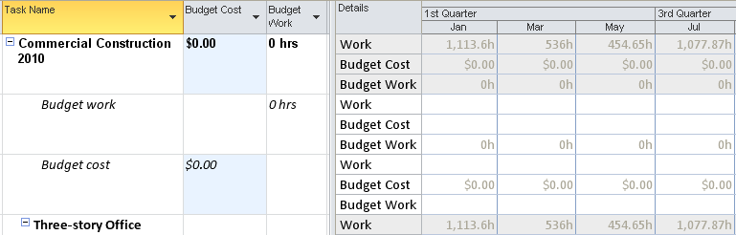

The last step is to enter the budget values in the Budget Work and Budget Cost columns. In the view below $1,000,000 was entered for the budgeted cost field and 10,000 was entered in the budget work field.

The numbers are fairly consistent with the per month values on the right side of the grid. Most projects are not this evenly distributed. For this reason, values may be entered on the right side to reflect an expected anticipated burn rate. The numbers in the Budget Cost and Budget Work columns, however, are not fixed. They are the sum total of the values entered on the right side of the grid.

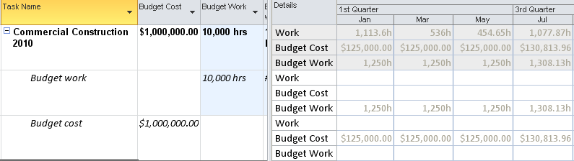

If the column is not wide enough to accommodate the size of the value, ##### will appear in the column. This can be resolved by dragging the column dividing lines to widen the column until the values appear correctly. This will react the same way as the autofit function for columns works in Excel.

## Practice: Working with Resources



*The Practice page is where you write detailed instructions for completing work listed as Exercises.*

*Type the Exercise Title and write a brief summary what the student will be doing in the exercise. Then list your ideas what they will be doing.*

*SAMPLE*

*In this practice you will create a Project Server Authentication profile and then configure the local cache settings in Project Professional 2007.*

*Exercise 1: Create Project Server Authentication Profile*

*In this exercise you will create Project Server authentication profile to connect to the Project Web Access site.*

Perform the following exercise on the PS07 virtual machine.

1. *From the* ***Start*** *menu, click* ***All Programs*** *🡪* ***Microsoft Office*** *🡪* ***Microsoft Office Tools*** *and click* ***Microsoft Office Project Server 2007 Accounts****.*
2. *In the* ***Project Server Accounts*** *dialog box, click* ***Add****.*
3. *In the* ***Account Properties*** *dialog box, and complete the following settings and click* ***OK****.*

|  |  |
| --- | --- |
| *Setting* | *Perform the following:* |
|  | |
| *Account Name* | *Type* ***Project Server*** |
| *Project Server URL* | *Type* ***http://epm/pwa*** |
| *When connecting* | *Select* ***Use Windows user account*** |
| *Set as default account* | *Select check box* |

# Summary



This module was intended to take an in-depth look at resources and how to best utilize them within a project schedule. As in any project, if the resources are not included, the project will not be accomplished.

In this module we discussed:

* Resource types available: work, material, cost and budget
* How to enter each of the resource types
* How to assign cost and material resources to tasks
* How to add fixed costs to tasks
* How to enter budget work and budget cost values for a project.